GROUP 6

Abhinit Kumar - 2023JULB01008

Palak Agarwal - 2023JULB01009

Parnal Khobragade - 2023JULB01119

Prince Pritam - 2023JULB01012

Srishti Mishra - 2023JULB01233

Yashveer Singh - 2023JULB01191

POWER BI GROUP PROJECT

# **BLINKIT SALES ANALYSIS:**

## 1. Problem Statement

Blinkit, formerly known as Grofers, is a key player in the online grocery delivery sector, which has seen rapid growth in recent years, fuelled by technological advancements and changing consumer preferences. However, this competitive and dynamic environment presents significant challenges that necessitate a data-driven approach to decision-making.

Blinkit’s business model relies heavily on delivering diverse product categories such as fresh produce, packaged foods, beverages, and household essentials to customers within short delivery windows. To sustain its competitive edge, the company must continually optimize its sales performance, customer satisfaction levels, and operational efficiency. Several issues hinder its ability to achieve these goals:

1. **Sales Performance Variability:** The company has observed varying levels of sales performance across different product categories, fat content classifications (e.g., regular fat vs. low fat), and outlets. While some items perform exceptionally well, others struggle to gain traction. Understanding the factors contributing to this variability is critical for optimizing product offerings.
2. **Inventory Challenges:** Managing inventory for a wide range of products across multiple outlets is inherently complex. Overstocks lead to increased holding costs and wastage, particularly for perishable items, while understocks result in missed sales opportunities and dissatisfied customers.
3. **Outlet Performance Disparities:** Blinkit operates in diverse geographic regions, ranging from Tier 1 metropolitan cities to Tier 3 rural towns. Sales data indicate that certain outlet types and sizes outperform others. However, the root causes behind these disparities—whether they stem from customer demographics, product mix, or marketing efforts—remain unclear.
4. **Customer Preference Alignment:** Consumer preferences, such as the demand for regular versus low-fat products, play a significant role in shaping sales trends. Blinkit needs to ensure that its product portfolio aligns with these preferences to maximize revenue and enhance customer satisfaction.
5. **Customer Feedback and Satisfaction:** While customer satisfaction levels are generally positive, there is a need to identify specific areas for improvement. Analyzing customer feedback alongside sales performance can provide actionable insights to elevate the overall customer experience.
6. **Operational Scalability:** As Blinkit continues to expand its operations to new regions and increase its product offerings, maintaining scalability and efficiency becomes a critical concern. Data-driven insights are essential to support decisions on outlet expansions, resource allocation, and product distribution.
7. **Demand Forecasting and Planning:** Blinkit struggles with accurately predicting demand across regions and seasons, leading to mismatches between supply and demand. A robust analysis of historical sales trends is needed to improve forecasting accuracy.

The overarching challenge for Blinkit is to harness the power of its vast sales and operational data to address these issues systematically. By analyzing its data, the company aims to uncover hidden patterns and trends that can drive better decision-making. The ultimate goal is to enhance operational efficiency, increase sales, and deliver exceptional value to its customers.

This project is designed to address these challenges by conducting a comprehensive analysis of Blinkit's sales data, customer behavior, and operational metrics. The insights derived from this analysis will provide actionable recommendations to improve inventory management, align product offerings with customer preferences, enhance outlet performance, and refine marketing strategies.

In the face of increasing competition from players like BigBasket, Zomato, and Dunzo, Blinkit’s ability to leverage its data assets effectively will play a pivotal role in securing its position as a market leader. This analysis represents a critical step toward achieving this objective and setting the foundation for sustained growth in the future.

## 2. Data Overview

The dataset used for this analysis captures comprehensive sales information across multiple Blinkit outlets, providing a detailed view of the company’s operational and sales performance. The data consists of multiple features that allow for in-depth exploration of sales trends, customer preferences, and outlet performance. The key components of the dataset include:

1. **Item Identifier:** Each product in the dataset is uniquely coded, enabling granular analysis at the product level. This allows for the identification of high-performing and underperforming items.
2. **Item Type:** Products are categorized into various types such as Fruits, Vegetables, Packaged Foods, Beverages, and more. This categorization facilitates the evaluation of sales patterns within and across product categories, aiding in inventory and marketing decisions.
3. **Fat Content:** Items are classified based on fat content, such as Regular Fat and Low Fat. This classification helps in understanding consumer preferences for health-conscious products versus traditional offerings.
4. **Outlet Identifier:** Each outlet is assigned a unique code to distinguish its sales and operational data. This feature allows for outlet-specific performance tracking and comparative analysis.
5. **Outlet Type:** Outlets are categorized based on their classifications, such as Tier 1 (metro cities), Tier 2 (semi-urban areas), and Tier 3 (rural towns). Analyzing data across these tiers provides insights into how regional factors influence sales.
6. **Sales Figures:** The dataset includes detailed records of total sales for each item, enabling the identification of high-revenue products and seasonal sales trends.
7. **Customer Ratings:** The inclusion of customer ratings reflects customer satisfaction levels and provides insights into areas where service quality or product offerings can be improved.

**Source of Data** :

The data originates from Blinkit's internal sales database, serving as a representative sample for analysis. This dataset captures historical records and key performance indicators (KPIs) essential for understanding Blinkit's business operations. It is provided in an Excel format, ensuring easy accessibility and usability for data cleaning, processing, and visualization.

The dataset represents a valuable asset for exploring various dimensions of the business, including product performance, customer behavior, and outlet efficiency. By leveraging this data, the analysis aims to uncover actionable insights to address Blinkit’s operational challenges, enhance customer satisfaction, and improve overall business performance.

The source's reliability ensures that the data is robust, relevant, and aligned with the company’s actual sales environment. This alignment is critical for drawing meaningful conclusions and formulating recommendations to drive Blinkit's growth and operational excellence.

## 3. Understanding from the Data

The data provides valuable insights into various aspects of Blinkit’s business, including item performance, customer preferences, outlet efficiency, and customer feedback. These insights highlight key trends and opportunities for optimization, enabling data-driven decision-making to enhance operational efficiency and customer satisfaction. Below are the detailed understandings derived from the dataset:

**Item Performance Analysis:**

* **High Sales Contribution from Fruits and Vegetables:** The data reveals that **Fruits and Vegetables** account for the largest share of sales. This indicates that these categories are the most in-demand among customers, emphasizing their importance in Blinkit's product portfolio. Ensuring consistent stock availability and quality in these categories is critical to maintaining customer satisfaction and sustaining high sales.
* **Strong Demand for Beverages and Snacks:** Beverages rank second in terms of sales, followed closely by Snacks. This trend reflects diverse customer demand across product lines. While beverages cater to hydration and refreshment needs, snacks fulfill on-the-go consumption preferences, highlighting the need for variety and targeted promotions in these categories.

**Fat Content Preference:**

* **Dominance of Regular Fat Products:** The analysis shows that **Regular Fat products significantly outperform Low Fat options** in terms of sales. This preference suggests that while health-conscious items have a growing audience, the majority of Blinkit’s customers prioritize traditional offerings. This insight is vital for shaping product mix strategies to cater to the broader customer base while retaining niche low-fat options for health-conscious consumers.

**Outlet Efficiency:**

* **Exceptional Performance of Tier 3 Outlets:** Tier 3 outlets demonstrate the highest total sales among all outlet classifications. This finding underlines the strong potential of non-metropolitan markets for driving revenue growth. Tier 3 cities likely represent an untapped market with loyal and frequent shoppers, requiring tailored strategies to sustain and expand this growth.
* **Impact of Outlet Size on Sales:** Larger outlets consistently perform better in terms of sales volume, indicating that size is a critical factor influencing customer footfall and inventory variety. Larger outlets can house a wider range of products, providing customers with more options, which translates into higher sales.

**Customer Feedback:**

* **High Customer Ratings with Room for Improvement:** The average customer rating is approximately **4 out of 5**, reflecting a generally satisfied customer base. However, there are opportunities for improvement to exceed customer expectations. Enhanced service quality, timely deliveries, and personalized offers could help elevate these ratings further, translating into improved loyalty and retention.

## 4. Analysis Conducted

The analysis of Blinkit’s data was carried out using **Univariate, Bivariate, and Multivariate approaches**, each focusing on unique aspects of the dataset. The aim was to derive meaningful insights into sales trends, customer preferences, and operational efficiency. Below is a detailed explanation of the analyses conducted:

### Univariate Analysis:

**Objective:** To explore and understand individual variables in the dataset, focusing on their distributions, trends, and key metrics.

**Example 1: Variable – Total Sales**

* **Insight:** Total sales data revealed that a majority of sales are concentrated in a few popular product categories, such as Fruits and Vegetables.
* **Visualization Used:** A **Bar Chart** was created to show sales volumes across categories.
* **Interpretation:** This insight emphasizes the importance of ensuring consistent stock and promotional activities for high-performing product categories to maximize revenue.

**Example 2: Variable – Outlet Type**

* **Insight:** Analysis of outlet types showed that **Tier 3 outlets consistently outperform Tier 1 and Tier 2 outlets** in overall sales.
* **Visualization Used:** A **Histogram** to visualize the sales distribution across outlet types.
* **Interpretation:** This insight highlights the need for strategic support to Tier 3 outlets, such as supply chain enhancements or targeted marketing campaigns, to capitalize on their strong performance.

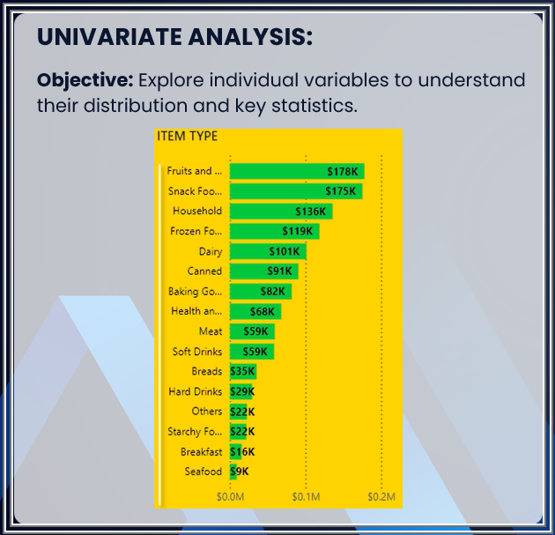

### Bivariate Analysis:

**Objective:** To investigate relationships between two variables and understand their influence on each other.

**Example 1: Variables – Fat Content vs. Sales**

* **Insight:** Products classified as **Regular Fat contribute to 70% of total sales**, significantly outpacing Low Fat items.
* **Visualization Used:** A **Donut Chart** was used to compare the sales contribution of Regular Fat and Low Fat products.
* **Interpretation:** Marketing campaigns should prioritize Regular Fat products to cater to customer preferences and maximize revenue.

**Example 2: Variables – Outlet Size vs. Sales**

* **Insight:** **Large-sized outlets demonstrate superior efficiency** in handling higher sales volumes compared to medium and small-sized outlets.
* **Visualization Used:** A **Stacked Bar Chart** illustrating sales performance by outlet size.
* **Interpretation:** Investment in expanding the size of high-performing outlets could significantly boost sales and improve operational efficiency.

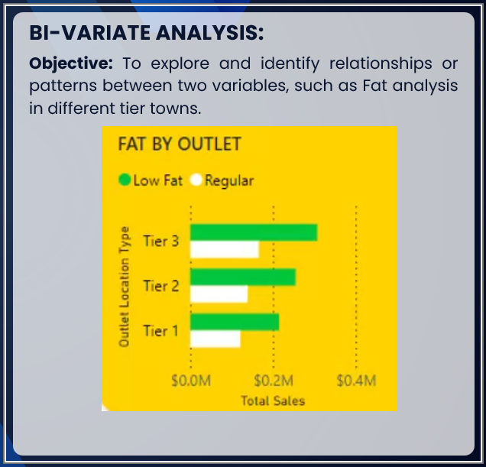

### Multivariate Analysis:

**Objective:** To examine the interactions and combined effects of multiple variables, enabling deeper insights into complex relationships.

**Example 1: Variables – Outlet Type, Fat Content, and Sales**

* **Insight:** Analysis revealed that **Regular Fat products in Tier 3 outlets drive the highest sales** across all combinations.
* **Visualization Used:** A **Heatmap** was employed to represent the relationship between outlet type, fat content, and sales.
* **Interpretation:** This insight suggests prioritizing Regular Fat product promotions in Tier 3 cities to maximize profitability.

**Example 2: Variables – Item Type, Visibility, and Sales**

* **Insight:** Items with **higher visibility consistently generate higher sales**, particularly in urban outlets.
* **Visualization Used:** A **Scatter Plot** to show the relationship between item visibility and sales.
* **Interpretation:** Enhancing product visibility through better placement or marketing can improve sales performance.

## 5. Graphs Created and Their Insights

**1. Histogram of Total Sales by Outlet Type**

* **Insight:** The graph clearly illustrates that **Tier 3 outlets dominate sales**, followed by Tier 1 and Tier 2 outlets.
* **Actionable Insight:** Focus more resources and marketing efforts on Tier 3 outlets to maintain and expand their sales momentum.

**2. Stacked Bar Chart of Fat Content by Sales**

* **Insight:** Products classified as **Regular Fat generate significantly more revenue** compared to Low Fat products.
* **Actionable Insight:** Allocate promotional budgets and inventory for Regular Fat products accordingly.

**3. Line Chart of Yearly Establishment Trends**

* **Insight:** A surge in outlet openings was observed in **2018**, reflecting the company’s successful expansion strategies.
* **Actionable Insight:** Study the factors that contributed to this success and replicate them for future expansion.

**4. Scatter Plot of Item Visibility vs. Sales**

* **Insight:** **Higher item visibility correlates directly with increased sales.** Products with better shelf placement and higher advertising recall perform significantly better.
* **Actionable Insight:** Optimize product placement strategies and explore innovative marketing techniques to improve visibility.

**5. Heatmap for Multivariate Analysis**

* **Insight:** The **combination of outlet type, fat content, and item visibility** significantly influences sales patterns. Tier 3 outlets selling Regular Fat, high-visibility items are top performers.
* **Actionable Insight:** Formulate targeted marketing and stocking strategies focusing on these high-performing combinations.

## 6. Overall Insights from the Analysis / Solving the problem statements:

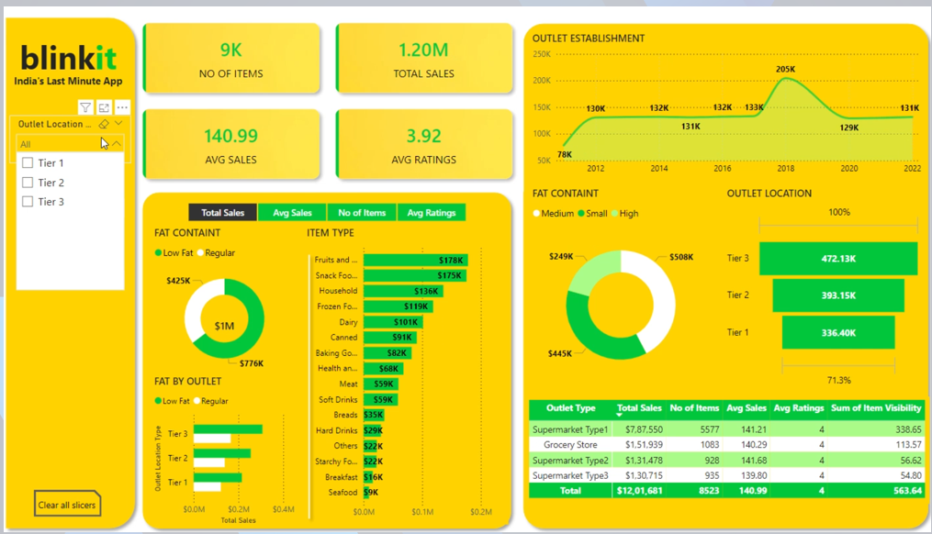

1. **Identify the top-performing outlet location type in terms of total sales.**

**Solution:** The dashboard visualizes total sales by outlet location type (Tier 1, Tier 2, Tier 3) on the right side. It shows that Tier 3 outlets have the highest total sales of $472.13K, indicating they are the top performers.

1. **Determine the most popular item type in terms of total sales.**

**Solution:** The bar chart in the middle section lists item types alongside their total sales. "Fruits and Vegetables" tops the list with $178K in sales, making it the most popular item type.

1. **Analyse the trend in outlet establishment from 2012 to 2022.**

**Solution:** The line graph in the top right corner shows the number of outlets established over time, revealing a peak in 2018 with 205K outlets and a general trend that can be used to understand business growth or decline.

1. **Evaluate the impact of fat content on total sales and outlet performance.**

**Solution:** The pie chart at the bottom left shows the breakdown of total sales by fat content (Low Fat vs. Regular), with regular fat items generating $1M in sales. Another chart shows how these sales vary across different outlet types, helping evaluate the impact.

1. **Identify which outlet type has the highest average sales per item.**

**Solution:** The table at the bottom right provides detailed data on total sales, number of items, average sales, and average ratings by outlet type. Supermarket Type 1 has the highest average sales of 141.21 per item.

1. **Determine the distribution of item visibility across outlet types.**

**Solution:** The table at the bottom right also includes the "Sum of Item Visibility" metric, allowing users to compare how well items are showcased in different outlet types, with Supermarket Type 3 leading in visibility.

1. **Assess the average ratings across different outlet types to identify customer satisfaction trends.**

**Solution:** The table at the bottom right displays average ratings by outlet type, with consistent ratings of 4 across all types, indicating a generally high level of customer satisfaction.

1. **Understand the sales performance of low-fat versus regular items in different tiers of outlets.**

**Solution:** The bar chart titled "FAT BY OUTLET" on the left side breaks down total sales of low-fat and regular items across different outlet tiers, showing their performance and preference in each tier.

## 7. Recommendations for Business:

**Inventory Optimization**: Focus on stocking high-demand categories (e.g., Fruits and Vegetables) in Tier 3 outlets.

**Marketing Strategies**: Highlight regular fat products in promotional campaigns to capitalize on consumer preferences.

**Geographic Expansion**: Increase investment in Tier 3 cities, leveraging their strong sales performance.

**Enhance Customer Experience**: Use feedback loops to identify improvement areas and boost customer ratings.

**Improve Product Visibility**: Enhance item visibility through better shelf placement and advertising, especially in urban outlets.

**Expand High-Performing Outlets**: Open new outlets following the Supermarket Type 1 model to replicate efficiency.

**Leverage Seasonal Trends**: Conduct seasonal promotions based on historical sales data to maximize returns.

**Data-Driven Pricing**: Use demand data to implement dynamic pricing strategies, balancing profitability and competitiveness.